ACCOMPLISHMENT REPORT
IT 205 & 205L –Geographic Information Systems
Month: August & September – Year: 2025
School Year: 2025 – 2026 1st Semester

DATE | ACCOMPLISHMENT | REMARKS  (Progress and deviations from the plan) *
August 18 – 22, 2025 | Orientation  - SLSU Vision, Mission, Goals, Objectives and Quality Policy  - Program Outcomes  - Course Outcomes  - Course Outline  - Course Requirements  - Gender Awareness and Development (GAD)  - Course Grading System  - Student/s with Special Needs  - Disaster and Risk Preparedness  Lecture Accomplishments:  - Explained the concept and importance of GIS, including how QGIS functions as an open-source platform for spatial analysis.  - Identified and accessed academic references related to GIS to support introductory discussions.  - Enumerated and differentiated the components of the QGIS interface (Browser Panel, Layers Panel, Map Canvas, Toolbars).  Laboratory Accomplishments:  - Conducted a practical session where students explored and identified the QGIS interface, focusing on panels, canvas, and toolbars.  - Practiced basic configuration of QGIS, such as enabling required toolbars and plugins, to prepare for future mapping tasks. | Accomplished,  Accomplished,  Accomplished
August 25 – 29, 2025 | Lecture Accomplishments:  - Discussed the QGIS data package, configuration, required toolbars, and plugins to support efficient map creation.  - Understood how GIS is applied in solving real-world problems through practical examples.  - Analyzed a case study by identifying the problem, its root cause, and the GIS-based solution.  Laboratory Accomplishments:  - Conducted a laboratory session on importing vector data into QGIS for building spatial layers.  - Practiced configuring vector and raster datasets to create meaningful maps.  - Applied basic symbology to differentiate and visualize spatial data clearly. | Accomplished,  Accomplished
September 1 – 12, 2025 | Lecture Accomplishments:  - Explained the principles of vector data, focusing on how they represent spatial features.  - Analyzed symbology methods such as single, categorized, and graduated symbols for effective data representation.  - Evaluated different labeling techniques and their importance in communicating spatial information.  - Designed sample map layouts in QGIS, emphasizing cartographic principles for clarity.  - Summarized findings from case studies and presented them in short reports to connect theory with practice.  Laboratory Accomplishments:  - Conducted practical tasks on importing vector datasets into QGIS for mapping exercises.  - Applied and tested different symbology styles to visualize attribute data effectively.  - Implemented labeling rules for spatial features, adjusting placement and styles for readability.  - Practiced creating basic map layouts that included essential elements such as scale bars and legends.  - Exported sample maps in different formats (PDF, PNG) for presentation and evaluation. | Accomplished,  Accomplished
September 15 – 19, 2025 | Lecture Accomplishments:  - Discussed advanced use of symbology and labeling to represent thematic data.  - Analyzed attribute data to link visual representation with real-world applications.  - Designed professional map layouts integrating legends, scale bars, north arrows, and titles.  - Evaluated different cartographic design choices for accuracy and clarity.  Laboratory Accomplishments:  - Conducted mapping tasks applying categorized and graduated symbology for attribute visualization.  - Practiced designing and editing map layouts using QGIS print layout tools.  - Integrated labeling rules with symbology to improve clarity of thematic maps.  - Exported maps in .shp formats and shared outputs for peer review. | Accomplished,  Accomplished
September 22 – 26, 2025 | Lecture Accomplishments:  - Explained principles of cartographic design for multidisciplinary and multicultural use of maps.  - Designed sample map outputs applying proper classification, color schemes, and labeling rules.  - Discussed professional and ethical standards in map design and data representation.  - Evaluated map outputs for readability, accuracy, and cultural sensitivity.  Laboratory Accomplishments:  - Conducted exercises on designing cartographically sound map layouts with all essential elements.  - Practiced exporting maps in multiple formats (PDF, PNG, TIFF) for professional use.  - Compared outputs from different groups to identify strengths and weaknesses in design.  - Refined maps based on peer and instructor feedback to improve clarity and presentation. | Accomplished, Accomplished
September 29 – 30, 2025 | Lecture Accomplishments:  - Summarized the overall applications of GIS in addressing real-world spatial problems.  - Reflected on the importance of open-source tools like QGIS for sustainable and cost-effective mapping.  Laboratory Accomplishments:  - Conducted final mapping exercises integrating vector data, symbology, labeling, and print layout into one comprehensive project.  - Exported and presented final map outputs in professional formats, demonstrating readiness for academic and professional use. | Accomplished,  Accomplished
*Provide relevant documentation such as pictures, summary reports, etc.

Prepared by: Approved:

JUNNIE RYH M. SUMACOT SHERWIN G. CADAY, PhD.
Instructor Program Chair

PROOF/EVIDENCE OF REPORTED ACCOMPLISHMENTS
IT 205 & 205L –Geographic Information Systems
Month: August & September – Year: 2025
School Year: 2025 – 2026 1st Semester

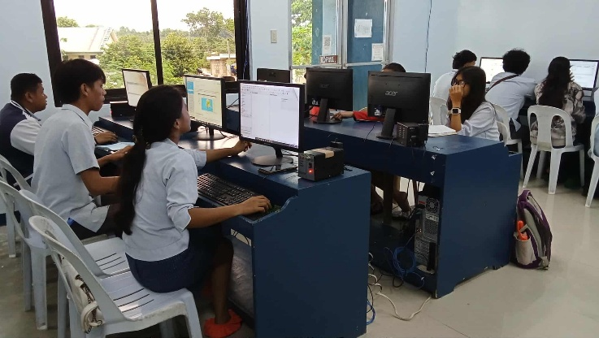
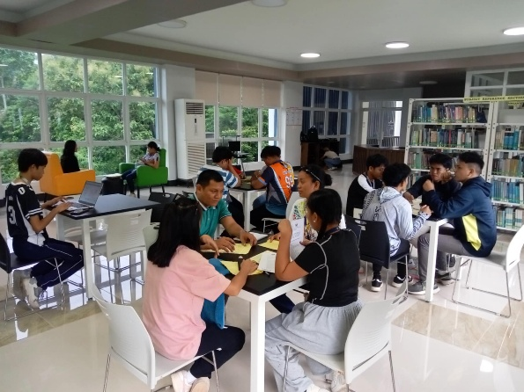
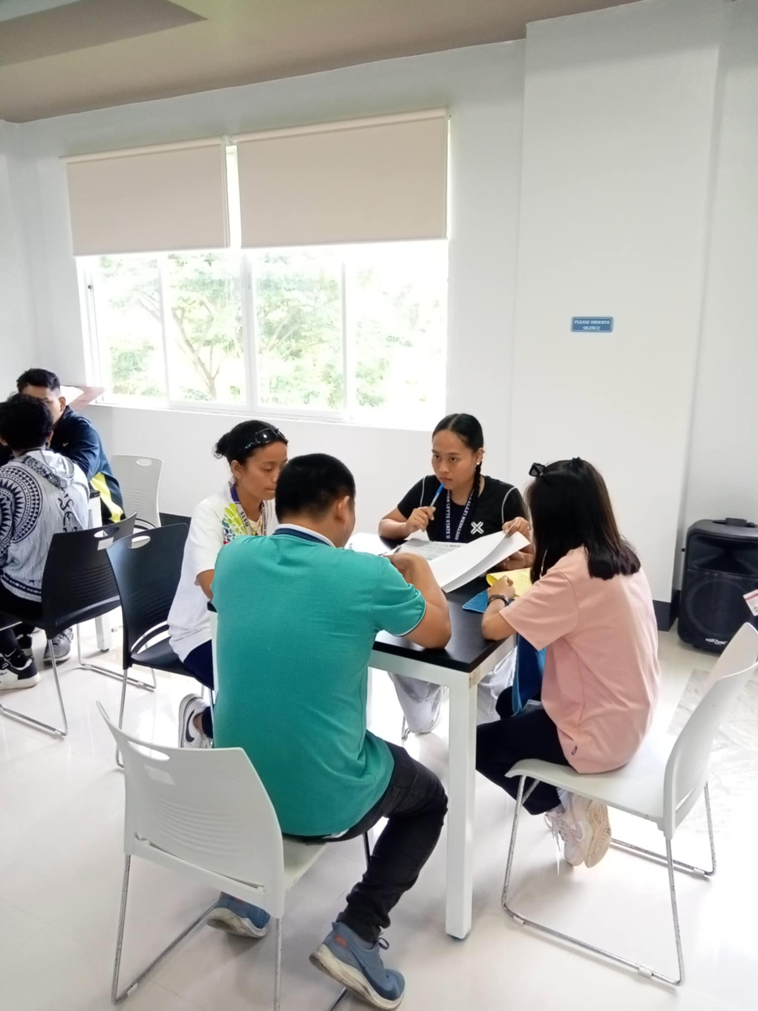
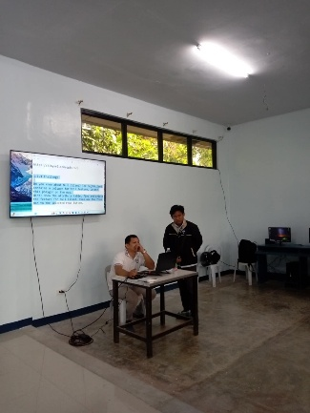

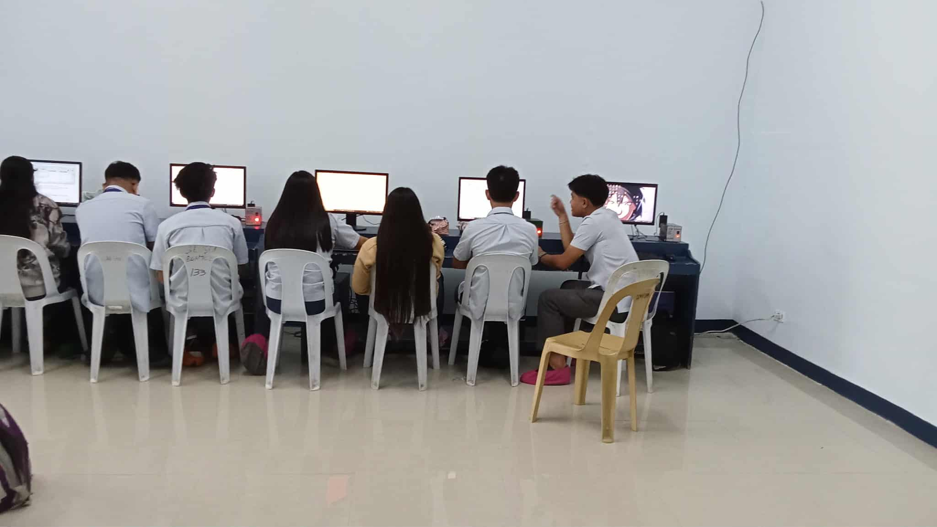
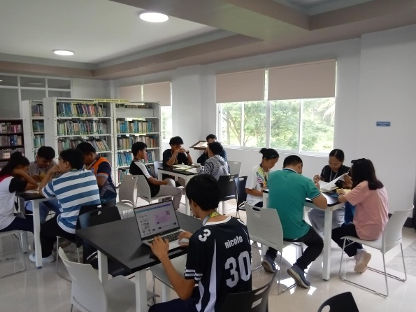

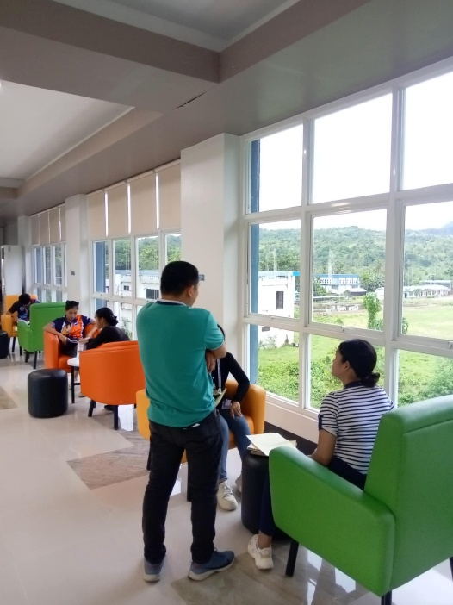
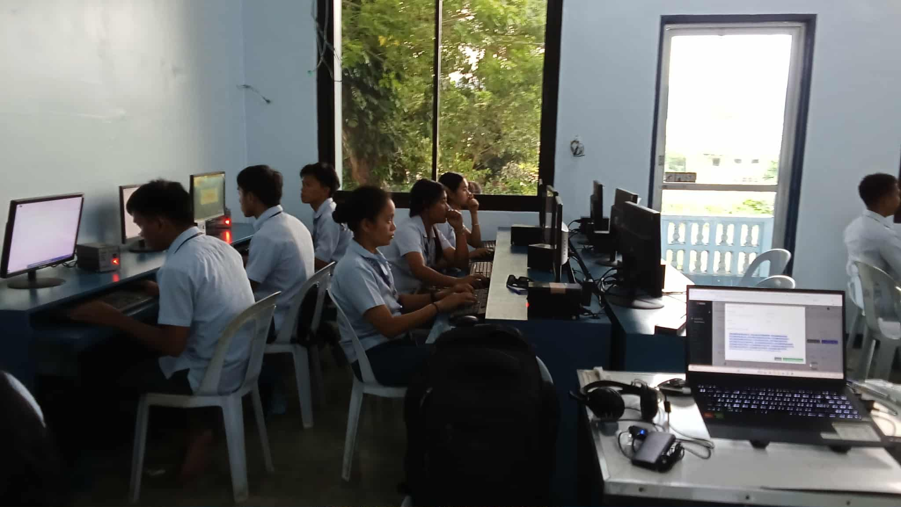
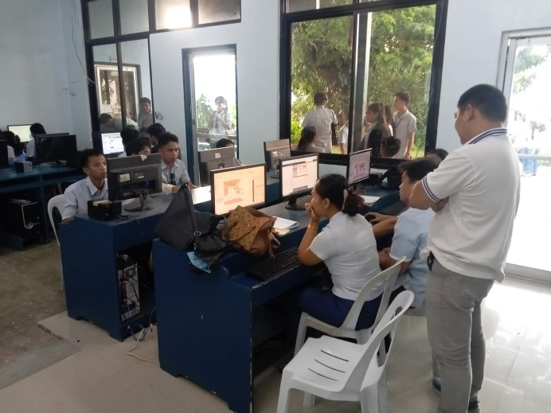

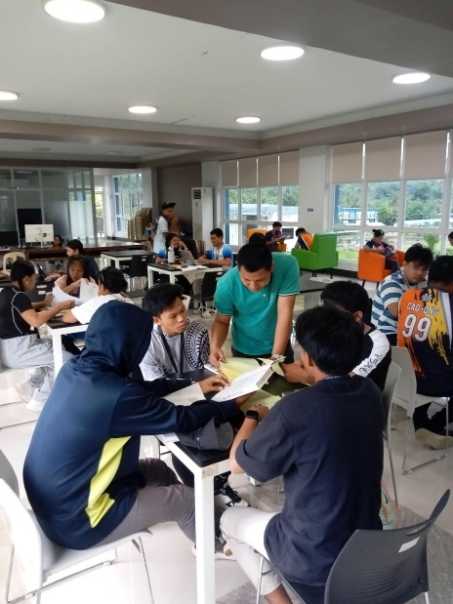

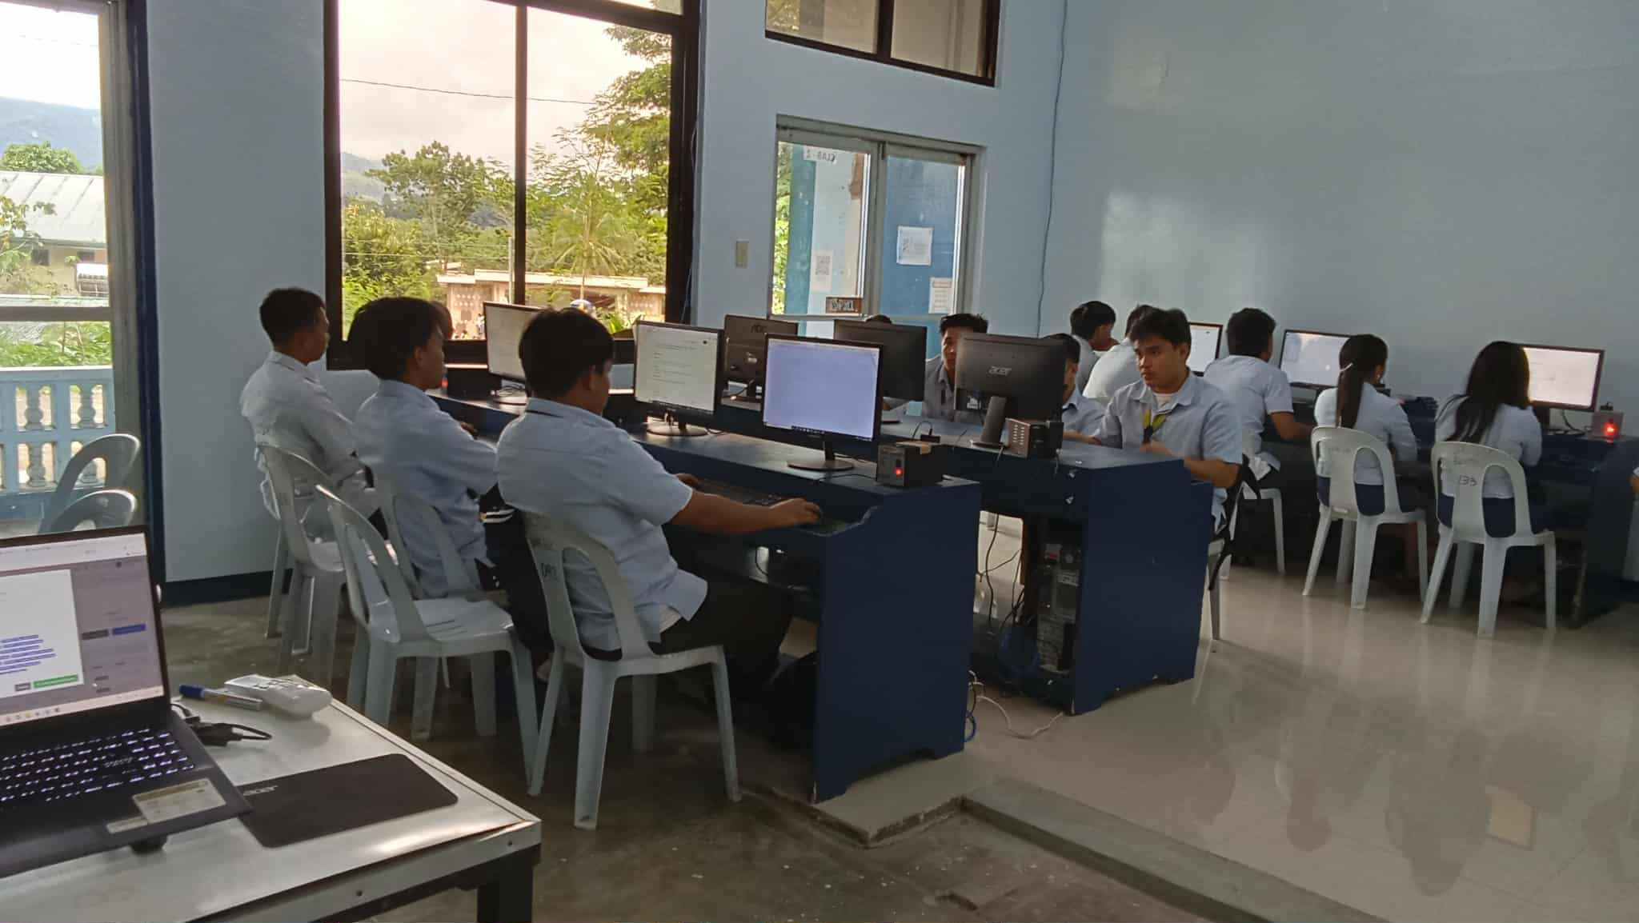
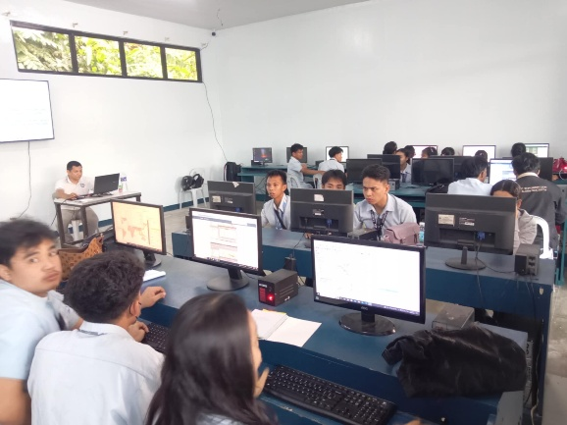

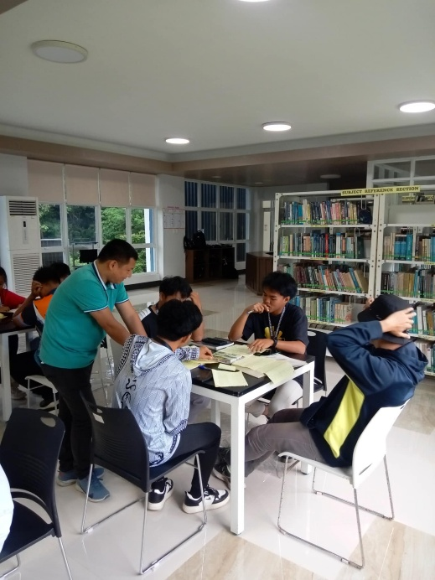
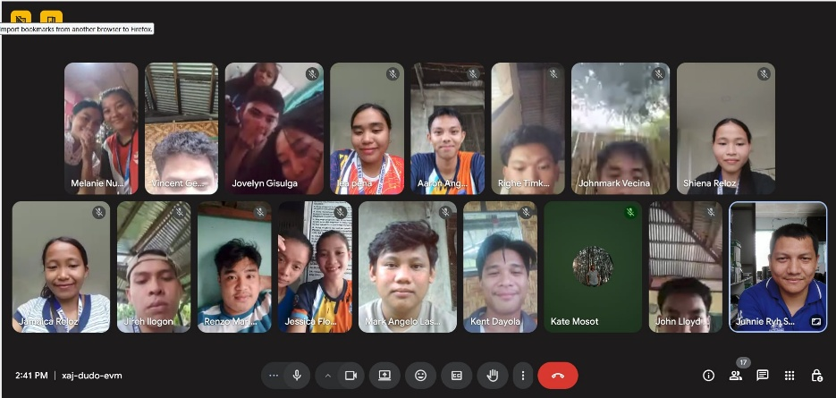
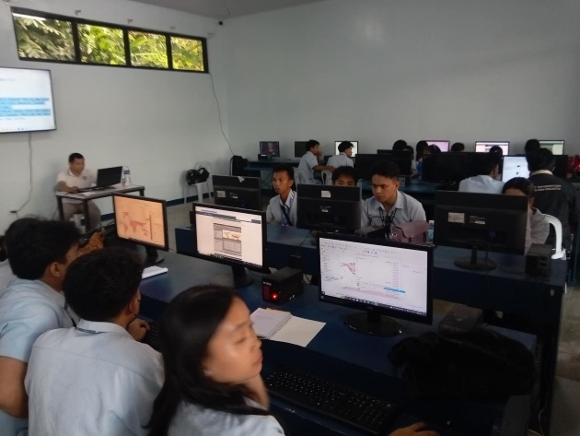

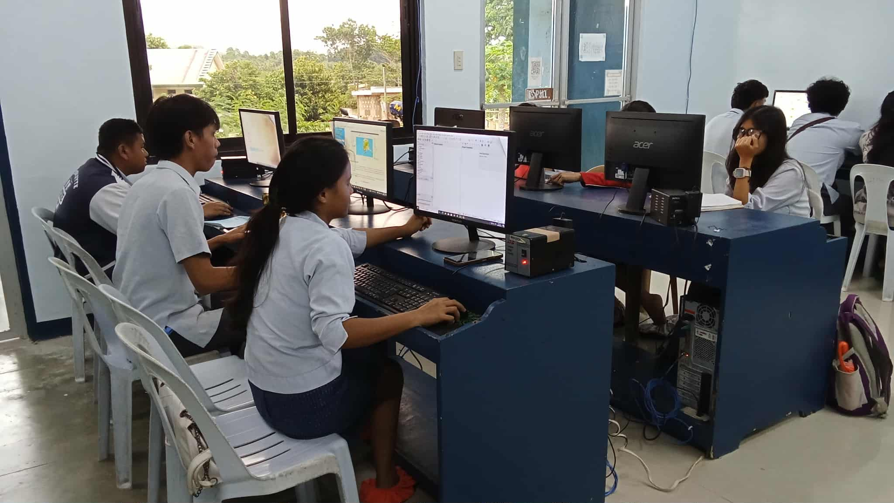

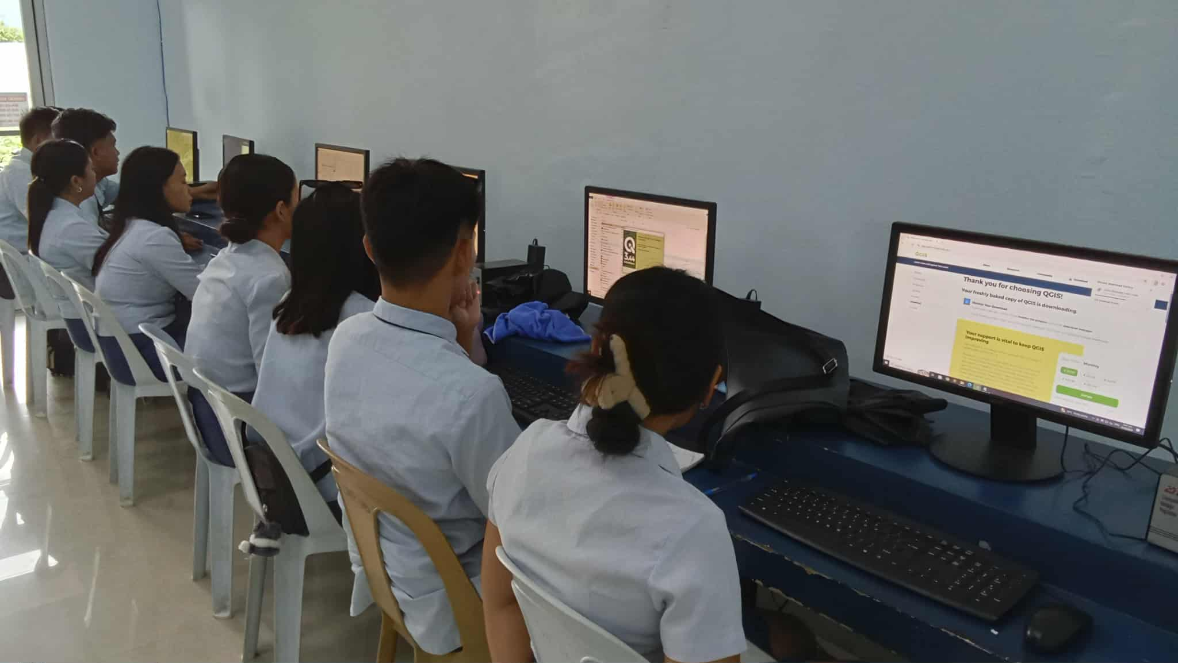

Prepared by: Approved:

JUNNIE RYH M. SUMACOT SHERWIN G. CADAY, PhD.
Instructor Program Chair

